
The presenting author named Shulei Zheng, 27 years old, is a Master of Science，who has working on the multimedia electronic atlas research for 9 years since gaining the admission to Zhengzhou Institute of Surveying and Mapping, China, 1998. And 3 years ago，she received the master degree in the major of cartography and GIS in this college in June 2005 and remains there today.

A NEW INTERFACE DESIGN METHOD OF MULTIMEDIA ELECTRONIC ATLAS BASED ON LOGICAL THEORIES

Shulei Zheng, Yufen Chen, Guosheng Zhang, Chunlei Yang
Zhengzhou Institute of Surveying and Mapping, Zhengzhou 450052, P.R.China
z_score2@163.com

ABSTRACT
With the rapid development of multimedia electronic atlas, the problem in design field is more and more visible. In order to solve interface design problems, this paper is divided into four parts, which fetches logical theories to the multimedia electronic atlas step by step.
At the first of this paper, some traditional design methods of Multimedia Electronic Atlas are classified.
Following this, some problems in the multimedia electronic atlas interface design are concluded, such as the lack of consistency, the mixed-up windows structure, the multimedia which work out of line, and etc.
Then, some logical theories are brought in the multimedia electronic atlas interface design. By researching on the Logical Atomism Theories And Principium Identitatis Theories, the Commonness Class Theories, the Principium Contradictionis Theories and Tertium Nondatur Theories, and the Principium Rationis Sufficientis Theories in turn, a new design method comes into being under the direction of logical theories above.
In the end, a new design methods based on logical theories above are introduced and practiced in the interface design of the Multimedia Electronic Atlas of Fujian Ecological Environment, which is designed by the author independently. Some pictures of the pages in it are also shown in this chapter.

KEYWORDS: LOGIC THEORY, MULTIMEDIA ELECTRONIC ATLAS, INTERFACE DESIGN

1 BACKGROUND
Although current multimedia electronic atlas can satisfy user desires like “Where can I learn” based on the plentiful maps and attributes data, or”How can I get there” based on the strong query functions, but they have not been so good at satisfying desires like “I want to use something or information in my own way.” Such desires, though, will become more common as part of the next-generation atlas applications. A good design can provide user with a high degree of freedom, minimize the disturbance, assure the user's safety, and improve the efficiency of the human-computer interaction^{[1]}.
This paper provides an new multimedia atlas interface design idea based on some logical theories to solve many problems in the multimedia electronic atlas interface design area. It is also a overview of the authors’ theoretical study and development work on the process of developing the Multimedia Atlas of Ecological Environment in Fujian.
The Multimedia Atlas of Ecological Environment in Fujian is a subsection of the project Ecological Environment Dynamic Monitoring and Management Information System in Fujian, which is one of the major application projects in Digital Fujian, China. There are several features in this multimedia atlas. One is the attractive and expressive interfaces using reasonably multimedia technologies, but not in traditional Windows forms. Another one is the thematic web of ecological environment inside it, in which many multimedia information contents can be clearly organized. And the other one is the acceleration of multimedia response speed to the user.^{[2]}

2 CLASSIFICATIONS OF THE INTERFACE DESIGN

The interface design is important because it is shown to the user firstly while atlas being opened. The elements of the interface include the map, miniature, toolbar, buttons, menus, query window, layer control window, etc. The design idea is often showed in the way of the type, layout, color choice of windows, buttons and menus, maps design and all kinds of media exertion.

There are many methods having been applied to the multimedia electronic atlas intereface design. Function-type or multimedia-type can be classfied in view of windows type, thick or thin in view of color.
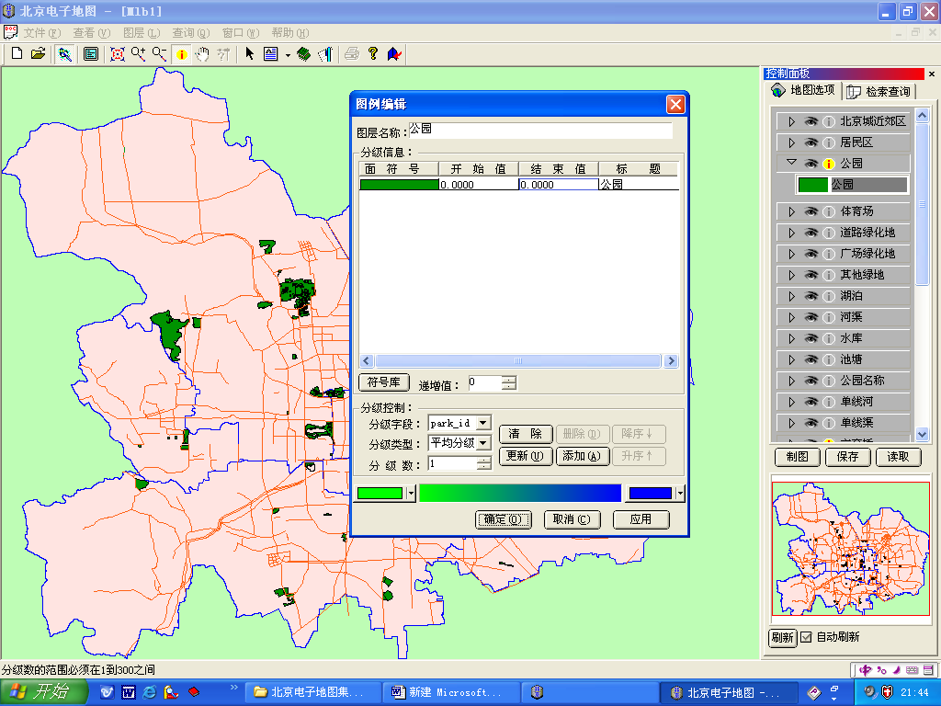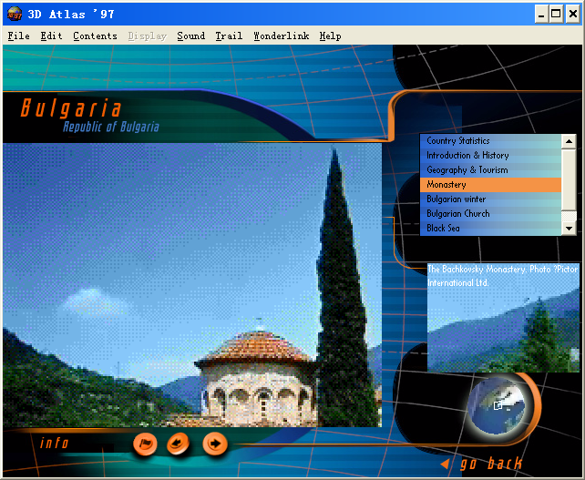
Figure1. the contrast of Function-type or multimedia-type window in the atlas
Considering on the layout, there are so many kinds of design methods. Lengthways-type includes up-down, down-up and up-mid-down( based on the relative positions relations of map, toolbar and function areas lengthways). Transverse-type includes left-right, right-left and left-mid-right( based on relations of relative positions of map, toolbar and function areas athwartships). Pop-up-window-type or Drawing-down-window-type can leave huge space to the map showing area. Another is compositive-type. It is wide freedom to design, but toolbar usually is arranged in the bottom.
As for the buttons and menus type only, it can be designed into icon-type, text-type and mix-type in static or dynamic state.
Taking account of the multimedia application, pictures, texts, musics and videos can be used very wide too, such as the cover pages, the sounds of buttons being clicked and the background music, etc. They can cooperate to enhance the effect of the whole atlas.

3 PROBLEMS IN THE TRADITIONAL INTERFACE DESIGN
With the rapid development of multimedia electronic atlas, the problem in design field is more and more visible, and it appears most serious in the interface design because of the neglect of theories research, the blindness in projects development and the systems design at random^{[3]}. Traditional design methods couldn’t get over some shortcomings which are listed in the following.

3.1 LACK OF CONSISTENCY
However, this is a universal problem. The disaccord is often put up between the part and the whole, between each of the function windows in one page, between the color of the maps in the same group, between the buttons and menus style, between each media or their uncooperation.
3.2 LACK OF HIBERARCHY
The simplest hiberarchy of the multimedia electronic atlas is whole atlas - map groups - maps. And the interface including the lower hiberarchy should be browsed in cognition order. It might disturb the used thought of the user if maps are arranged out of order.
3.3 INDISCRIMINATE FUNCTIONS
In one side, simplistic function design can’t meet user’s need. On the other side, overladen function design is a burden, too. Modest functions design predicate modest function buttons in the limited interface area at the same time.
3.4 INADEQUATE MULTIMEDIA COOPERATION
There are two kinds of problems in interface multimedia design. One is ignoring the relations between the maps and multimedia, another is responding too slow. When it happened, the user might be too fantod to keep at using the atlas.
3.5 OTHER PROBLEMS
The problems in the atlas design is much more than the above. Weak interaction, suspect link buttons, or blurry function tips around the bottons and menus are insufferable also.

4 SOLUTIONS BASED ON THE CORRELATIVE LOGICAL THEORIES
In order to solve the interface design problems above, some logical theories are brought in the interfaces design. They are listed out in the following.
4.1LOGICAL ATOMISM THEORIES AND PRINCIPIUM IDENTITATIS THEORIES
According to Logical atomism theories, the multimedia electronic atlas can be decomposed into elements, atomism elements and object elements.^{[4]}
Principium Identitatis Theories can be used to regulatethe the design of layout, color, buttons and menus style, etc. Taking the buttons design for example, the style and the color of buttons in atlas are usual designed in the same way, but the tips and functions of them are different at all.
4.2 COMMONNESS CLASS THEORIES
The relation between maps, map groups and whole atlas is maps ∈map groups ∈atlas. Thereinto, maps are the low-class, map groups are the mid-class, and atlas is the high-class. In the gap of every two class, other classes is permitted. Multimedia can be divided into texts, pictures, videos, sounds and cartoon movies according to the character of every sorts of media. So, the Commonness Class Theories can be used to direct the hiberarchy design.
4.3 PRINCIPIUM CONTRADICTIONIS THEORIES AND TERTIUM NONDATUR THEORIES
The Principium Contradictionis Theories and Tertium Nondatur Theories can be used to help to solve the problem of indiscriminate functions. The way which buttons and menus answered to the user should be settled. When operation happened, the certain respondence should be shown in the right way that the user just expected. It can be explained why the Modest functions design is essential.
4.4 PRINCIPIUM RATIONIS SUFFICIENTIS THEORIES
The Principium Rationis Sufficientis Theories says, “Everything linked with others via the relations which is in impersonale existence.” In the multimedia electronic atlas interface design, multimedia means is the effective complementarity of the information which is gotten from maps and attribute data. All the kinds of means synthetically act to the user to show general information being concerned about by the user.

5 NEW METHODS AND PRACTICE CASE
The logical theories above provides novel design methods to satisfy user individual desires. Instead of working as independent parts, all the interface elements operate in a cooperative and comprehensive manner. Based on all researches above, we apply the new design methods to the Multimedia Electronic Atlas of Fujian Ecological Environment to prove the feasibility of these methods based on the logical theories, and explain how to design a better multimedia electronic atlas. Some particular pages is described below.
The content of the Multimedia Atlas of Ecological Environment in Fujian can be divided into seven maps groups including the basic maps group, the ecological environment background maps group, the ecological resource maps group, the ecological environment pollution and destroy maps group, the ecological environment protect maps group, the ecological environment rebuild maps group, the ecological environment observation, research and estimation maps group, and an inside web named “Ecological Web of Digital Fujian”.^{[9]}
5.1 CONSISTENCY
Under the direction of the Logical Atomism Theories And Principium Identitatis Theories, in the Multimedia Atlas of Ecological Environment in Fujian, the function windows, the map showing window, the flash menus, the function toolbar buttons and the buttons linking to other map pages(turning forward, backward, to the start and to the end) are designed in the fix position and style in every map page. Red tool buttons made in Flash with effect of 3d, dynamic, rotate, having tips when the mouse wandering about, are listed in a line at the bottom. Menus liking to other maps in the same group are in popping style listed in a row at the right. Green buttons at the bottom of the right make users can go backward, forward or exit freely at any time. The color of the map’s name are consistent in every same maps group, but different in different map groups. In addition, all kinds of multimedia, such as cartoons and music, videos and explications, buttons and sounds, pictures and texts, etc, get on well with each other, too.
5.2 HIBERARCHY
Under the direction of the Commonness Class Theories, the framework of this atlas is hyper-media net structure. Maps are organized by different themes. Different maps in the same class link with each other. Whether map groups or multimedia contents are organized in the nodes and chains. Maps groups, main maps and other maps are three level nodes. Chains can be recognized as structure chain of “catalog - Maps Groups - Main maps - Other maps” and logical chain of “Coordinate Data - Attribute Data - Multimedia Data”. Every node can be turned to the others freely by the linking menus and buttons.
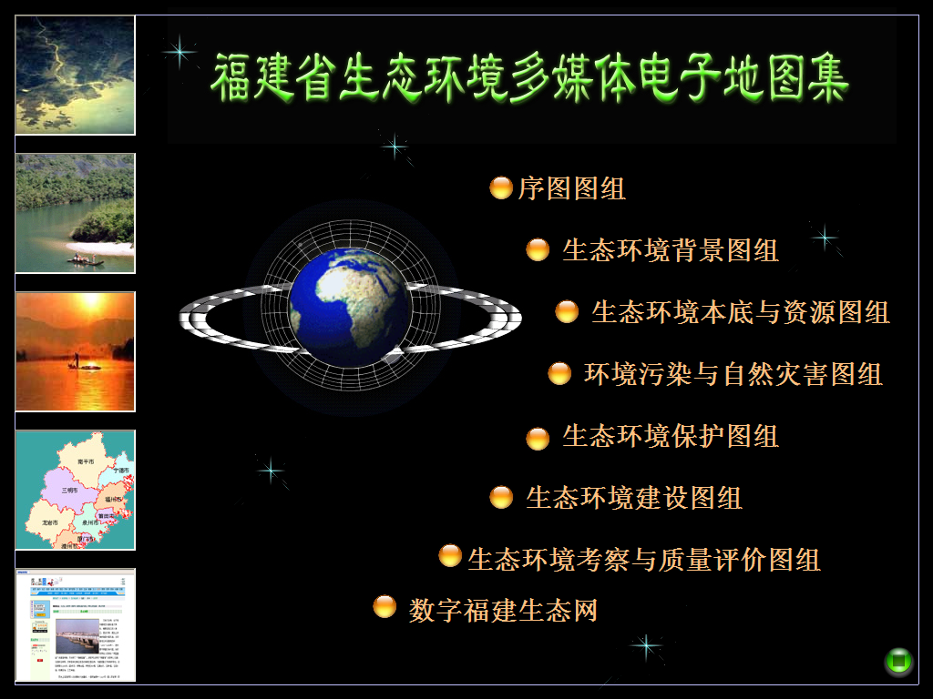
Figure2. the map group chosen page design in the atlas
5.3 MODEST FUNCTIONS
Based on the Principium Contradictionis Theories And Tertium Nondatur Theories, the map pages are composed of map showing block, information querying block, layer controlling block, common tools block, etc. The function buttons is shown in the picture below. It is obvious that there are no redundancy, and it can meet the need of the users of this atlas completely.
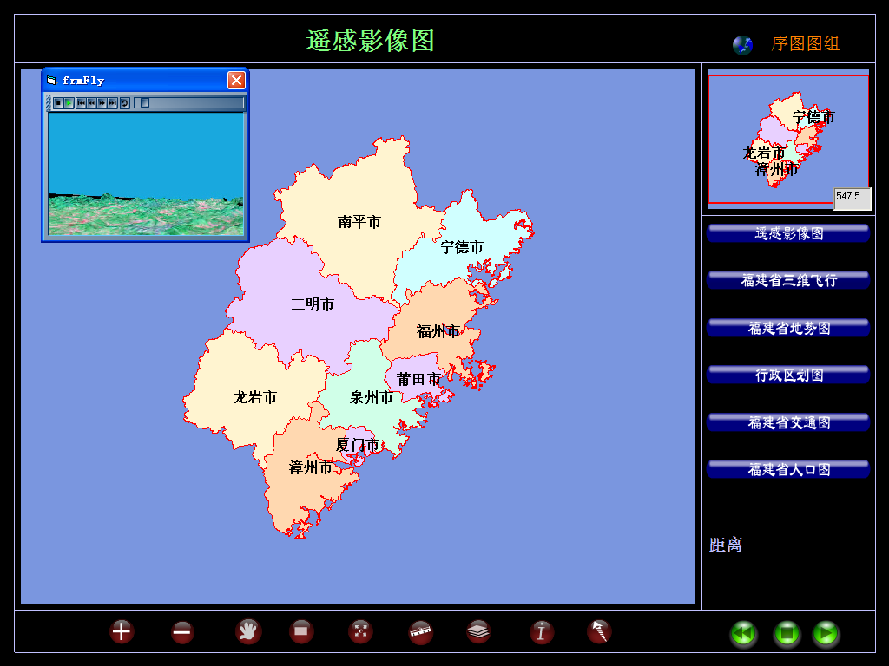
Figure3. the common map page design
5.4 COOPERATION BETWEEN MAPS AND MULTIMEDIA DATA
Geo-data are stored in the relative database, and media-data are stored in the media files database. The path and name of multimedia files are noted in the attribute database. According to the Principium Rationis Sufficientis Theories, when the attribute record that matches the coordinate record is visited, the multimedia information can be operated. When the hot point, hot line or hot area on the map being reached, the satellite images and DEM data are shown in the pop-up windows, too.
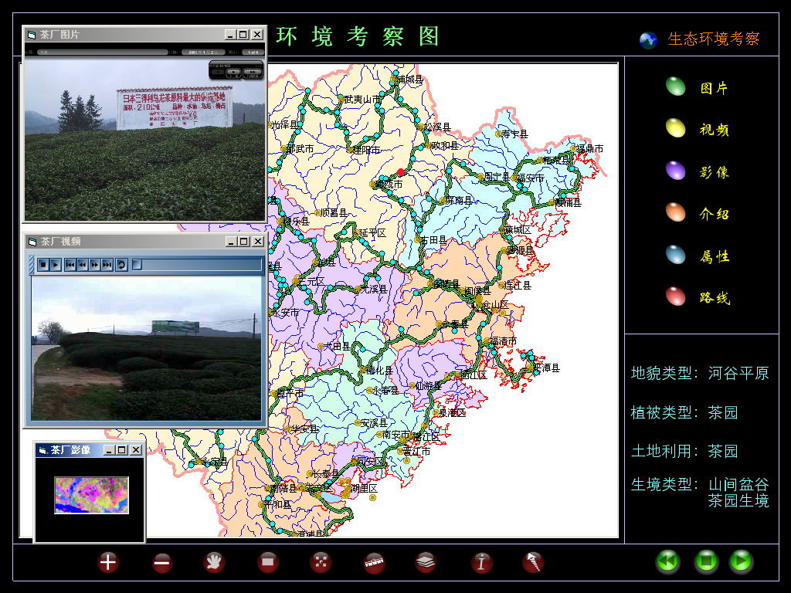
Figure4. the multimedia information querying interface design
5.5 WEB PAGES INSIDE
There are laws, maps, introductions, typical animals and plants on ecological environment. A great deal of data on ecological environment is organized in the web inside the atlas, so that every kind of data can be divided and managed ring upon ring with reason. Music design is indispensable and the audio player we designed in it can be controlled by the users self.
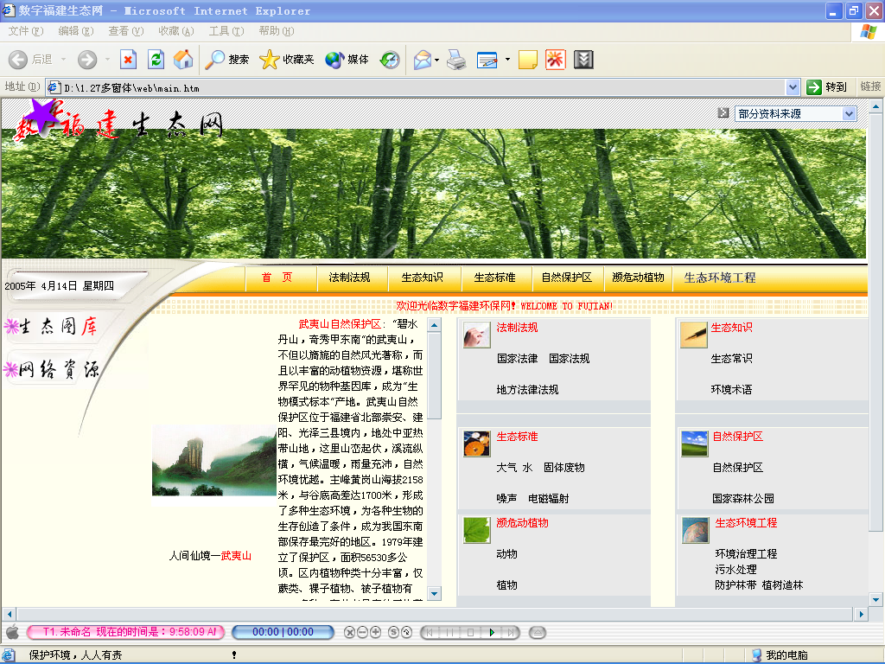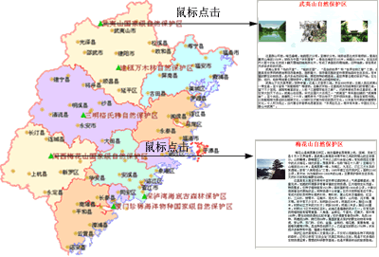
Figure5. web page inside the atlas

REFERENCES
[1].Yang Zhaosheng. Lu Shoufeng and Wang Chuanjiu. Human-computer interface design for an in-vehicle information system. Intelligent Transportation Systems, 2003. Proceedings. 2003 IEEE.Volume 2, Issue , 12-15 Oct. 2003 P.1417 - 1421 vol.2
[2].Zheng Shulei and Chen Yufen.The Principles of Designing CIS-Cartographic Information System.Proceeding of the 12th International Conference on Geoinformatics. June. 2004 P.389-P.396.
[3].Kretschmer, I..Theoretical Cartography: Position and Task.International Yearbook of Cartography.Vol.ⅩⅩ. 1980
[4].Zheng Shulei. The research on the multimedia electronic atlas design based on the logical theories. Master's degree paper. Zhengzhou Institute of Surveying and Mapping, China. Jun. 2005
[5].Hans Rudolf Bär and René Sieber.Atlas of Switzerland-multimedia Version: Concepts, Functionality and Interactive Techniques, Proceedings of the 18th International Cartographic Conference Vol. 2. 1997 P.1141-1148.
[6].Hans Rudolf Bär and René Sieber.Towards High Standard Interactive Atlases: The “GIS and Multimedia Cartography” Approach.Proceedings of the 19th International Cartographic Conference. 1999
[7].Wang, Y., Chen, X, and Yu, Z..The Development of Electronic Atlas in China.Proceedings of the 21st International Cartographic Conference. 2003
[8].Edsall, R.M. Challenging conventions for geovisualization interface design: implications for exploratory data analysis. Information Visualisation, 2005. Proceedings. Ninth International Conference on Volume , Issue , P.642 – 647. 2005.7
[9] Zheng Shulei and Chen Yufen. Multimedia Atlas of Ecological Environment in Fujian: Design and Implementation. Proceedings of the 22th International Cartographic Conference. Oral Themes 14 Sessions 2 Paper2. 2005

